A.1
CREATE DATABASE CollegeDB;
USE CollegeDB;
CREATE TABLE OnlineEnrollment (
StudentID INT PRIMARY KEY,
StudentName VARCHAR(50) NOT NULL,
Course VARCHAR(30),
City VARCHAR(30),
Marks INT
);
CREATE TABLE OfflineEnrollment (
StudentID INT PRIMARY KEY,
StudentName VARCHAR(50) NOT NULL,
Course VARCHAR(30),
City VARCHAR(30),
Marks INT
);
INSERT INTO OnlineEnrollment
VALUES
(1, 'Rahul Sharma', 'BSc IT', 'Mumbai', 78),
(2, 'Priya Patil', 'BCA', 'Pune', 85),
(3, 'Aman Verma', 'BSc CS', 'Nashik', 67),
(4, 'Sneha Joshi', 'BSc IT', 'Mumbai', 91),
(5, 'Karan Mehta', 'BCA', 'Thane', 74),
(6, 'Neha Shah', 'BSc IT', 'Pune', 88);
INSERT INTO OfflineEnrollment
VALUES
(4, 'Sneha Joshi', 'BSc IT', 'Mumbai', 91),
(5, 'Karan Mehta', 'BCA', 'Thane', 74),
(7, 'Rohan Desai', 'BSc CS', 'Mumbai', 69),
(8, 'Meera Kulkarni', 'BCA', 'Nashik', 82),
(9, 'Arjun Nair', 'BSc IT', 'Thane', 59),
(10, 'Divya More', 'BCA', 'Mumbai', 93);
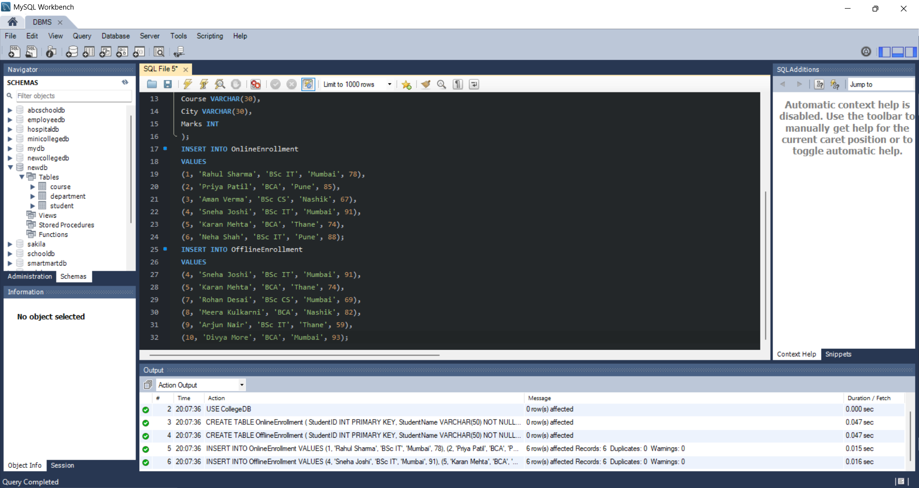

A.2
SELECT StudentID, StudentName, Course, City, Marks
FROM OnlineEnrollment
UNION
SELECT StudentID, StudentName, Course, City, Marks
FROM OfflineEnrollment;
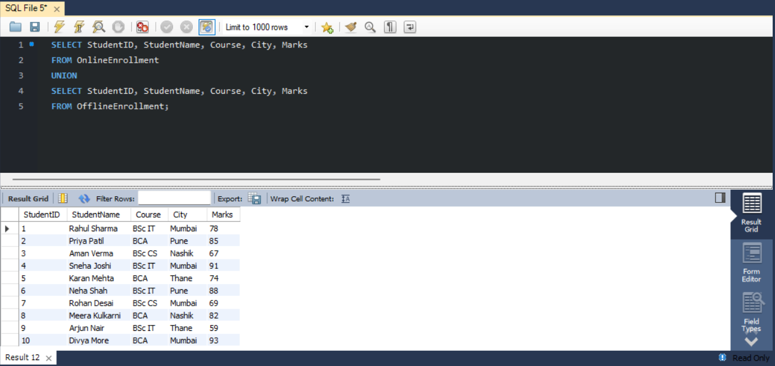

A.3
SELECT StudentID, StudentName, Course
FROM OnlineEnrollment
UNION ALL
SELECT StudentID, StudentName, Course
FROM OfflineEnrollment;
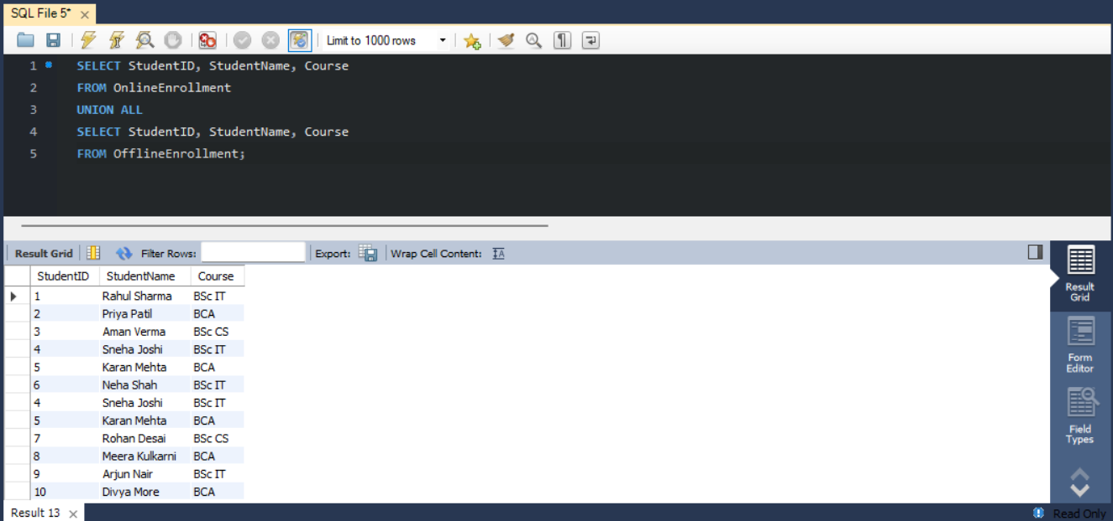

A.4
SELECT StudentID, StudentName, Course, City, Marks
FROM OnlineEnrollment
WHERE StudentID IN (
SELECT StudentID
FROM OfflineEnrollment
);
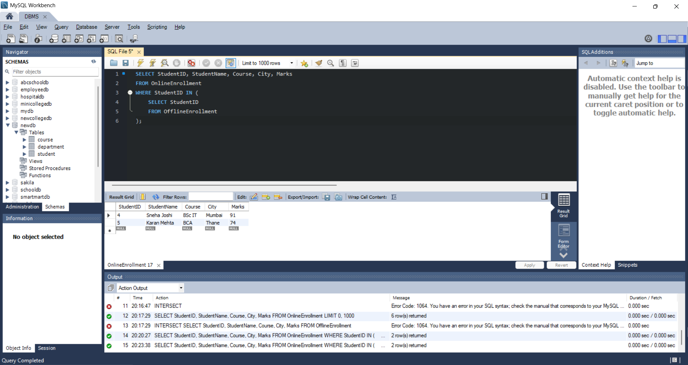

A.5
SELECT StudentID, StudentName, Course, City, Marks
FROM OnlineEnrollment
EXCEPT
SELECT StudentID, StudentName, Course, City, Marks
FROM OfflineEnrollment;
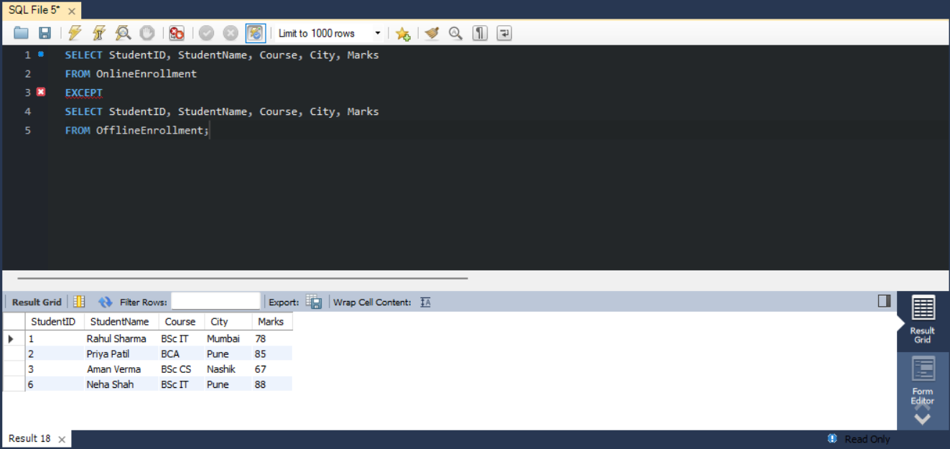

A.6
SELECT StudentID, StudentName, Course, Marks
FROM OnlineEnrollment
WHERE Marks >= 85
UNION
SELECT StudentID, StudentName, Course, Marks
FROM OfflineEnrollment
WHERE Marks >= 85
ORDER BY Marks DESC;
